Modern Solutions Management Capacity Hydraulic Pumps Using Frequency Regulation

J. Erić Obućina +, S. Čajetinac +, S. Stankovski ++, and G. Ostojić++
⁺ College of Technical and Mechanical Engineering, Radoja Krstica 19, 37240 Trstenik, Serbia
Phone: (037) 714-121, Fax: (037) 714-121, E-Mail: jericobucina@gmail.com
⁺⁺ Department of Industrial Engineering and Engineering Management, University of Novi Sad, Faculty of Technical Sciences, Trg Dositeja Obradovica 6, 21000 Novi Sad, Serbia, Phone: (021) 485-2168, E-Mail: stevan@uns.ac.rs

Abstract - The development of hydraulic power transformer monitors the development of the hydraulic pumps to the application of regulatory capacity, and with the achievement of greater energy savings in the system. In an effort to pump capacity in the hydraulic system adjusts the requirements of the machine that drives developed an increasing number of regulators, hydraulic - mechanical devices, often with electronic control. Pressure regulators, power, hydraulics, servo and LS regulator only basic structures depending on the application site to expand management control components, and sometimes mutually merged. Development of electronics creates new spaces for the development of hydraulics, not only in the field of construction components but also management systems. The total development is aimed at streamlining the modalities of structural and hydraulic components in our efforts to improve the energy efficiency ratio of the hydraulic system and minimizes the total installed capacity of the drive motor pumps. Know the principles of transformation of mechanical into hydraulic energy in the pump, its transport to the actuator and the mechanism of re-transformation into mechanical energy. Within these, the basic functions, the design of the hydraulic drive must meet other important requirements - energy losses along the way must be minimal. Hydraulics and electronics in recent years, intense complement each other, so that in a certain field applications with hydraulic pumps - electronic controllers replaces pumps with constant specific volume variable speed control (control frequency converter). The result of the development of electronics is improving construction of frequency converters that are installed in systems with hydraulic pumps with the task of following a pre-defined program in the CPU regulate the pump capacity variable speed. This paper provides an overview of the application of hydraulic gear pumps with constant capacity and frequency converter in the hydraulic system to be achieved by varying the flow over the cycle.
Key words: Hydraulic gear pump, frequency converter, the pump capacity

I. INTRODUCTION
Converting hydraulic energy into mechanical and vice versa takes place in the components of the hydraulic system - hydraulic pumps and motors. The transfer of power to the hydraulic systems is done using fluid, incompressible fluid. For incompressible fluid is true that his volume will change significantly under the influence of external forces. [1]
The hydraulic system as used for more than one hundred years and during that lifetime has experienced a large number of structural transformation. Classic distribution valves with end positions of the working piston is adapted to the requirements of construction and manufacturing mobile machines so they are reducing the volume and weight, and increasing operating pressures, flow, speed and accuracy of response time, service life, reliability and efficiency ratios. At the moment when this and other improvements cannot be successful and/or rational to meet the requirements, there are new structural forms of hydraulic components. First, at the end of the Second World War servo, then proportional to the last decades of intensive develop different constructions built-in valves, hydraulic and solenoid control. Development of electronics creates new spaces for the development of hydraulics, not only in the field of construction components but also management systems. [4]
In the context of the basic functions of the hydraulic system, the transformation of energy, construction of the hydraulic system must meet other important requirements. The requirement is that the energy losses in the way of the transformation of energy must be minimal.
The total energy loss in the hydraulic system occurs as a result of: a) pressure drop, b) volume losses within components, c) non-compliant pump performance (higher capacity and higher pressure) with a maximum and required [1], [4].
The losses are due to the pressure drop can be reduced constructions of hydraulic components that provide the required pressure in the system. When reducing the volume of losses in the hydraulic system, in fact, an adjustment to the pump with the requirements that occur in the system. This means that at any moment should follow the work of the hydraulic system and meets the requirements that are necessary in this moment.

II. REGULATION OF CAPACITY VOLUME PUMPS IN THE HYDRAULIC SYSTEM

A. Regulation of capacity volume pumps
From the known relationship of fluid power failure, pressure and flow:
(1)
the ratio of the total, useful and power loss due to loss of fluid power pressure and flow is displayed in the form of diagrams (P = p ⋅ Q) - Fig. 1.
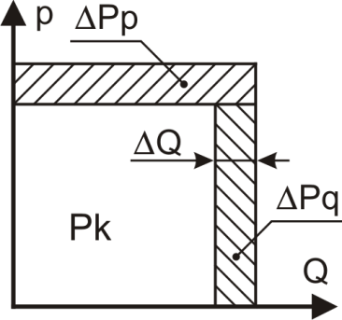
Fig. 1. Total available capacity hydraulic pumps
The total amount of pump power is distributed to usable power, which is marked with P_{k}, and the loss of power that is lost power due to falling pressure - ΔP_{p} and lost power due to the loss of flow - ΔP_{Q}.
The pressure drop and flow in the hydraulic system as a result of losses in the hydraulic components and for them it can be said that they are within acceptable limits, normal. However, if within the hydraulic system reduces the damping oil flow, with the unchanged requires pump pressure is increased to a level that is adjusted to the pressure limiting valve. [1] [4]
All the losses that occur in the hydraulic system serves to reduce the coefficient of utilization of the hydraulic system.
In order to fit the requirements of the hydraulic system that requires the work process itself, there are different types of regulation of basic hydraulic sizes. Thus we have control on the flow line, the pressure line and the plotted strength. [1] Types control are given in the following figure.
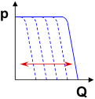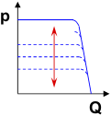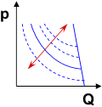

Fig. 2. Principles of regulation capacity volumetric pump capacity per line, pressure and power curve
Good regulation characteristics of the hydraulic pumps are:
- the ability to manage and control stations duplex operation and the formation of closed hydraulic circuits;
- capacity regulation is changing the specific volume, not speed, and inertial forces do not affect the speed of response;
- controlling the position of the working elements of the pump can be internal or external pressure;
- specific volume control is performed in the entire range of the declared capacity (0 to qmax);
- short response time is dependent on the size of the specific volume pumps - ranging from 50 to 350 ms;
- the possibility of hydraulic constraints of the pump (pressure - on the basis of regulation of pressure or power capacity to the internal or external pressure);
- the possibility of electronic controls occupied the position of the working elements of the pump in relation to the set value and the correction system feedback;
- in a state change does not alter the noise level.
The main disadvantages of hydraulic controllers are:
- limit the installation on the basis of the construction work elements pumps - can be mounted on the rack, orbit and other pumps, in which it is not possible to change the working volume by moving the working elements;
- the complex structure;
- c) the cost of the controller increases proportionally with increasing demands.
B. Changing the volume capacity by changing the pump speed - frequency converter
Frequency inverters are electronic devices that allow speed control of three-phase asynchronous motors by the input supply voltage and frequency constant values ​​are converted into variable size. Control principle and characteristics of the speed control of an asynchronous motor is functionally different from the direct-current control system and servo motors. [1], [4], [3]
Frequency converters were first applied in centrifugal pumps for water transportation. The water supply systems, with the centrifugal pump, it is necessary to operate the pump characteristic so that the necessary capacity is maintained in the function of pressure and vice versa. [3]
In the last twenty years, in parallel with the development of the construction, improvement of technical characteristics and decline in prices per kW of power, drives increasingly find application in construction and hydraulic systems. For such a trend was a necessary development of the design of gear pumps, actually their breakthrough in the area of ​​higher working pressures (250 to 300 bar) and higher capacity.
The advantages of using frequency converters are:
- programming continuous speed control at constant torque;
- the possibility of programming the ramp;
- the definition of time run;
- a relatively high degree of accuracy repeat of the situation;
- the permissible short time overload up to 50%;
- increasing the speed and capacity of the pump in relation to the face and others.
The most important characteristics that limit the scope of the hydraulic drive are:
- delay in response speed due to the shifting weight of the rotor electric motors and pumps;
- insufficient controls to achieve the programmed capacity,
- limit the minimum allowable speed pumps;
- high production costs;
- narrow field of application of pumps of constant capacity and others.

III. APPLICATION OF FREQUENCY REGULATOR IN HYDRAULIC SYSTEM FOR REGULATING CAPACITY GEAR PUMPS
Gear pumps belong to the group pumps with a constant working volume. They belong to the group of volume pump in which the operating means for the suppression of the working liquid two coupled gears. One of the drive gear and receives torque of the drive unit, usually an electric motor, and the second driven gear.
Volume of fluid to be pushed depends on the speed and the size of place between the tooth. Gear pump is a kind of displacement pumps where it is not possible to regulate the capacity of the regulator installation capacity.
Due to the inability installation of hydraulic controller and regulating capacity that makes this pump, the paper presents the application of the frequency converter for the purpose of regulating the number of revolutions of the engine. In this way we achieve that, a simple and reliable hydraulic pump, the hydraulic system may provide variable flow rate as a function of the number of revolutions.
The following figure shows a hydraulic system with gear pump, hydraulic energy source and frequency converter, as well as an electronic component that regulates the pump capacity.
The system works so that, when starting, includes an electric motor as a power source, and the frequency at which the regulator sets the reference pressure value that he wants to maintain the system. By activating the command that the system is put into operation hydraulic pump is started and in accordance with the desired output, ie. reference value to be reached at the executive body ie. hydraulic cylinder, maintains the set value.

Components of the hydraulic system are:

1 hydraulic power pack, 2 - hydraulic valve, 3 - safety valve, 4 - hydraulic cylinder, 5 - hydraulic cylinder for load, 6 - hydraulic accumulator, 7 - frequency converter, 8- PLC CP1L, 9 - a module for acquisition CP1W-MAD11, 10 - DC mudule 24V, 11 - computer, 12 - pressure transmitter, 13 - manometer, 14 - clutch.

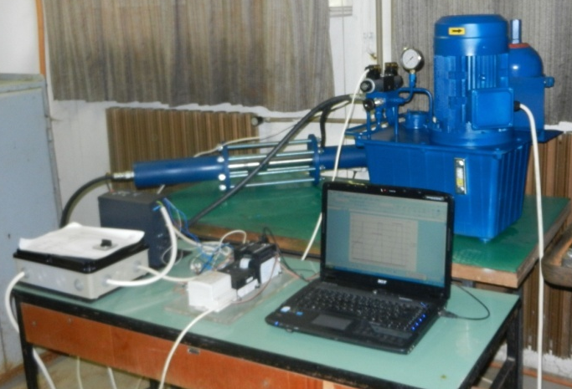
111
9
3
1
2
4
5
6
8
10
7
12
13
141
Fig. 3. The hydraulic system of regulation capacity gear pump frequency converter
Frequency converter, which serves as the controller has in it integrated PID regulator that maintains a reference pressure. Frequency converter, slightly run-up pump, and then change the speed to pressure remained on the set value.
Data on the actual value of the pressure supplied via pressure transmitter mounted on a hydraulic cylinder, precisely at the point where the pressure measured in the hydraulic cylinder, and is directly connected to the frequency converter.
In the event of a major higher the required force, the frequency converter will be changed over speed electric motors and thus will increase the pump flow rate, as it will be needed and higher pressure value that is directly related to the force of the hydraulic cylinder.
Also, in case that is needed less force, the hydraulic pressure on the executive body that would, through feedback, respond frequency regulator that will reduce the number of revolutions of the drive shaft has a hydraulic pump and it will give a smaller flow.
Another variant of this experimental work is that the frequency converter is controlled via PLC, which would then pressure value received from the transmitter and sending a command to the frequency converter.
The results that have been generated during the experimental part of the city are shown in Fig. 4 and determine the dependence of the number of revolutions of the electric motor and the pressure in the hydraulic system.
From the diagram, it is seen that when changing speed electric motor and changing the pressure in the hydraulic system.
In the case of the first variant, ie. when done directly manage frequency converter which still regulates the necessary force to the hydraulic cylinder, PLC has a role for data acquisition. Which means that the PLC and the module for acquisition connected to a computer, and custom set values and compares them with the reference signal in a closed loop.
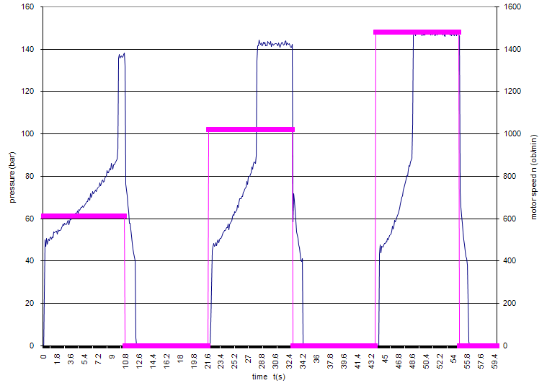
Fig. 4. Diagram depending on the pressure in the hydraulic system and the number of revolutions of electric motors
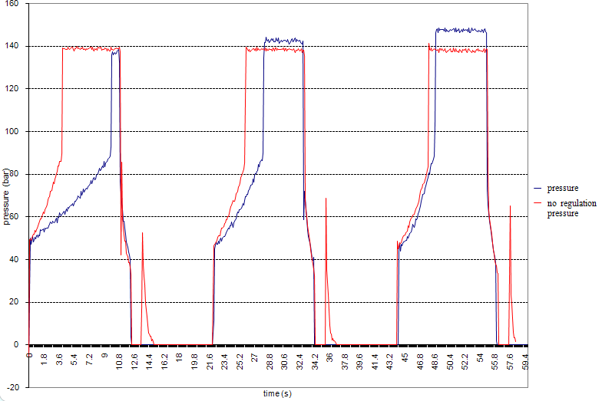
Fig. 5. Pressure with and without speed control motors
In the context of this paper I criteria and recorded the results of which indicate the energy savings in the hydraulic system.
Saving energy is very important in hydraulic systems because the system itself is not working at maximum pressure for each load and no-load pumps.
These savings are automatically mirrored to the application of the frequency converter, for comparing the system with and without regulation it can be read. For this kind of experiment give measurement of engine power consumed, as well as of the electricity required for operation of the hydraulic system.
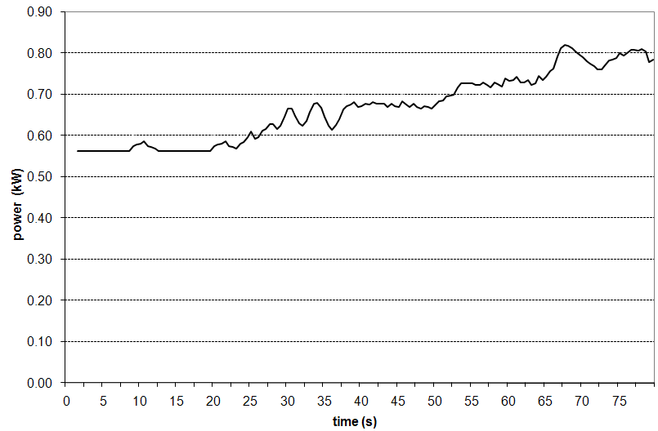

Fig. 6. Diagram depending on input power electric motors in relation to time and the required reference value
The diagram shows the pressure difference of pressure with and without regulation.

IV. CONCLUSION

In this study, data analysis and experimental data show that the use of the frequency converter in the hydraulic system useful. Designed hydraulic system in which the pump is replaced by a variable capacity pump whose capacity is altered by changing the number of revolutions, removes all doubt about a possible replacement of conventional hydraulic controllers with frequency converters.

When the hydraulic system in which it is possible to substitute the variable capacity pump with a constant pump capacity and frequency converter, a dominant influence on the application of the system of regulation of pump capacity has a price-performance ratio and energy conservation. Energy saving is confirmed by experimental results obtained in this paper and shown graphically in Fig. 6.

Area viability of the application of frequency regulator in relation to hydraulic, with the same capacity of the pump depends on the pressure and everything is on the higher range of applications of frequency converters is narrow and vice versa. There is no universal rule, so every hydraulic system and the pump must be the subject of a specific analysis or an exceptional profit for hydraulic systems where the pump can be replaced by a variable capacity pump capacity constant with frequency converter.

In addition, the use of frequency converters enables better control of the parameters that affect the operation of the pump.

REFERENCES
- V. Savić, Uljna hidraulika 4, deo 1, IKOS Novi Sad, 2014.
- Merritt, H. E., Hydraulic control systems, John Wiley & Sons Inc., New York, 1967.
- W. Leonhard, Control of Electrical Drives, Springer, 1996.
- Savić V., Erić Obućina J., Knežević D., Ivanišević A., Balović B., Kizić S., Technical-economic view of the replacement of pumps with variable volume pumps a constant volume of the frequency converter, 12. International Conference on Accomplishmants in Electrical and Mechanical Engineering and Information Technology DEMI 2015, 29-30. maj 2015., Banja Luka
- Wu H. W. Lee, C. B., Influence of a relief valve on the performance of a pump/inverter controlled hydraulic motor system, Mechatronics Vol. 6, No. 1, pp 1-19, 1996.
- V. Savić, Uljna hidraulika 4, deo 2, IKOS Novi Sad, 2014.
- H.Exner, R. Freitag, Hidraulics Basic Princips, Bosch Rexroth, 2011.
- E. Gnesi, J-C. Maré, J. L. Bordet, Modeling of EHA Module Equipped with Fixed-Displacement Vane Pump, The 13th Scandinavian International Conference on Fluid Power, SICFP2013, June 3-5, 2013, Linköping, Sweden
- M. Wang and P. Y. Li, Passivity based adaptive control of a two chamber single rod hydraulic actuator. In Proc. of The 2012 ACC, Montreal, Canada, 2012.
- D. Lovrec, S. Ulaga, Pressure control in hydraulic systems with variable or constant pumps?, Experimental Techniques, Vol. 31, No. 2, 33-41, 2007.
- M. Xu, B. Jin, G. Chen, J. Ni, Speed-control of energy regulation based variable-speed electrohydraulic drive, Strojniski vestnik - Journal of Mechanical Engineering, Vol. 59, No. 7-8, 433-442, 2013.

